PO Box 2630
Corvallis, OR 97339
541 714-3070
www.cascadepacific.org
______________________________________________________________________
SIUSLAW STEWARDSHIP WATERSHED RESTORATION PROGRAM (SSWRP)
FY 2024 Stewardship Fund Proposed Project Application
The following application is for projects located in the Alsea, Hebo, Marys Peak, Siuslaw, and Smith-Umpqua-Dunes Stewardship areas (see Map in Appendix A) surrounding the Siuslaw National Forest (SNF). Projects must meet the eligibility criteria and guidelines for permitted project types (see Appendix B).
The Siuslaw Stewardship Watershed Restoration Program (SSWRP) Fund (see Appendix C for background) provides approximately $400,000 annually, to support landowners and managers a funding source to improve and restore fish and wildlife habitat on private and other non-federal lands where there is demonstrated benefit to national forest lands. The exact amount of the fund may vary annually depending on the completion of stewardship timber sales, which generate the funds for this program. Funds are distributed on a shared basis among the five Stewardship Groups. Projects with at least 25% match funding or in-kind contributions are favorable; however, match is not a requirement for funding.
Project ideas are presented to the Stewardship Group in which the project is located. Pre-Applications (Section 1 of this application) are submitted by email to Cascade Pacific RC&D (CPRCD) and reviewed by the SNF Program Managers. Full Applications are submitted after pre-approval for technical review. The SNF technical team reviews projects to ensure they meet certain requirements to comply with federal law, regulations, and policy as well as ensure technical soundness. Input will be provided to applicants to include in their final application. Please see below for deadlines.
The SSWRP partnership program has been in operation since 2002. Approved projects have contributed to thousands of acres of restored forests, rivers, meadows and other habitats that support the plants, animals, soil, water and people that live in the Siuslaw watershed. We look forward to seeing new or continued projects that promote our effort to protect the watershed, its inhabitants and our local communities. Please contact Connie Barnes, connie@cascadepacific.org for assistance and questions regarding the application process.
SUBMISSION DEADLINES
Dec 1, 2022 | SSRWP RFP Released and PRE-Application/Application available online
Dec. 2022 - Jan 2023 | Project proposals discussed at Stewardship Group (SG) meetings and with SNF
January 31, 2023 | PRE-Application due to CPRCD
February 3-28 | SNF Natural Resource Staff and Stewardship Board review PRE-Applications
March 1 | CPRCD notifies Applicants of approval to proceed to full application status
March 21 | Full Applications due to CPRCD
March 28 - April 29 | SNF Technical Team (TT) Review of Applications
May 2 | CPRCD forwards TT comments to Applicants
May 3-31 | Applicants develop responses to TT comments with assistance from SG’s
By June 2-24 | TT reviews Applicant responses and forwards final comments to CPRCD
June 28 | Applicants receive final comments.
July and/or August | SG’s meet to prioritize projects
September 12-29 | Roundtable meets to prioritize applications for SSWRP funding
October 14 | FINAL Revised Applications due to CPRCD
December 1, 2023 | Letter of Approval from SNF Forest Supervisor
Early 2024 | Funding obligated by the SNF and contracts awarded to Applicants by CPRCD

Contents
Section I: Pre-Application Review 3
A. Request, Match, and Total Project Amount 3
B. CONTACT INFORMATION 3
C. Project Location Information 3
D. Required Project Maps and Photos 4
E. Proposed Project Type and Measurable Outcomes Expected 4
F. Project Goals, Benefits, Description, Problem and Proposed Actions 5
G. Project Review by SNF Technical Team 6
Pre- Application is COMPLETE! 9
Section II: Budget, Work Plan and Outreach 10
A. Budget Development and Detail Explanations 10
B. Stewardship Fund Scope of Work and Payment Plan 10
C. Educational/Public Awareness Opportunities (Cannot be paid for by Stewardship funds) 10
Section III: Qualifications and Required Reporting and Monitoring 11
A. Project Designer Qualifications and Design Elements 11
B. Project Technical Engineering Design Requirements 11
C. Project Inspection and Annual Progress and/or Final Report Submittal 11
D. Project Maintenance and Post Project Monitoring Report and Inspection 11
Section IV: Permit and Licenses 11
A. Permits or Licenses required to implement Project 11
Section V: MATCH FUNDING FORM 13
Section VI: LANDOWNER/APPLICANT CERTIFICATION FORM 14
Section VII: LEGAL REQUIREMENTS FORM 15
APPLICATION CHECKLIST 16
APPENDIX A: MAP OF STEWARDSHIP GROUP AREAS 17
APPENDIX B: Eligibility Guidelines for Stewardship Fund Projects 18
A. PROHIBITED Project Types and Activities 18
B. ACCEPTED Project Types and Activities 18
C. ACCEPTED Project Implementation Activities (that may be included but are not limited to) 19
APPENDIX C: Siuslaw Stewardship Restoration Program (SSWRP) Fund History 20
APPENDIX D: Common Mitigation Measures 20
APPENDIX E: Vicinity Map Examples 22
APPENDIX F: Site Plan Map Examples 24

Section I: Pre-Application Review
The Pre Application has been repurposed to determine the “readiness” of a project and not the eligibility of a project to fit the Wyden criteria. Projects brought forth should be well thought out adequately addressing the questions “how” things will be accomplished as well as “why here, why now.” For a project being considered but not yet ready with the following details, please work with Forest Service specialists and your local Stewardship Group before applying. The program operates on an annual cycle. Please review Appendix B to determine a project’s eligibility. Contact the Stewardship Program Manager if you still have questions.
Date | Pulldown Date Menu.

Request, Match, and Total Project Amount
Request Amount: $ | Match: $ | Total Cost of Project: $

CONTACT INFORMATION

Name of project:
OFFICIAL APPLICANT
Applicant Name |  |  | Position
Organization |  |  | E-mail
Address |  |  | Phone
City, State, Zip |  |  | Fax
PROJECT MANAGER (if different than official contact)
Name |  |  | Position
Organization |  |  | E-mail
Address |  |  | Phone
City, State, Zip |  |  | Fax
IF APPLICABLE:
OTHER FEDERAL AGENCY CONTACTS
Contact 1 Name |  |  | E-mail
Title |  |  | Phone
Office Location |  | Designated NEPA lead?*
STATE/LOCAL AGENCY CONTACTS
Name |  |  | E-mail
Street |  |  | Phone
City, State, Zip |  |  | Fax
*Verify if they are planning on covering any NEPA/SHPO requirements

Project Location Information
This project occurs at (check one): ☐ single site ☐ multiple sites
The project is for (check one): ☐ single year ☐ two years ☐ three years
Project location (general description):
Click here to enter text.
County: Choose County.
Township Choose Township. Range Choose Range.
Section (s) and ¼ Section(s).
Click here to enter text.
Longitude: Click here to enter text.
Latitude: Click here to enter text.
Stewardship Area: Choose Stewardship Area
Drainage Area (10 Digit HUC Watershed and/or 12 Digit HUC Subwatershed): Click here to enter text.
If available submit GIS Spatial mapping files of project area including: .shp, .shx, .dbf or .sbn. If not, follow map requirements listed below.

Required Project Maps and Photos
- Vicinity/Location Map and Site Map - Both maps must orient north/south, and include a title, north arrow, legend, nearest highway and city (Vicinity map), local road to access project, and project boundaries.
- Pre-Project Photos (four per page, maximum of two pages)
- All maps and photos must be embedded in the Pre and Final Application pdf, not sent as attachments. To do this, save this word application document as a PDF and add the maps and photos, so they are all in one PDF.
- See Appendix E for examples of Vicinity and Site Maps.

Proposed Project Type and Measurable Outcomes Expected
Indicate Project Type and all Applicable activities:
Vegetation Management/Treatment: Select all applicable activities
- ☐ Planting
  - ☐ Meadow planting (Enter # of pieces and area treated )
  - ☐ Tidal/estuary planting (Enter # of pieces and area treated )
  - ☐ Upland forest planting (Enter # of pieces and area treated )
- ☐ Site Prep (if annual maintenance of weeds choose invasives control)
  - Check all methods that will be used:
  - ☐ Mechanical (Enter acreage, area, or distance )
  - ☐ Manual (Enter acreage, area, or distance )
  - ☐ Herbicide (Enter acreage, area, or distance )
  - Check all methods that will be used:
  - ☐ Mowing (Enter acreage, area, or distance )
  - ☐ Pulling (Enter acreage, area, or distance )
  - ☐ Thinning (Enter acreage, area, or distance )
- ☐ Seedling Protection (Enter # of pieces or plants )
- ☐ Piling and/or Burning (Enter area and/or # structures )
- ☐ Snag or downed woody debris creation (Enter acres and quantity created by piece )

Invasive Plants Control: Select all applicable activities
- ☐ Riparian invasive plant control
  - ☐ Manual (Enter acreage, area, or distance )
  - ☐ Mechanical (Enter acreage, area, or distance )
  - ☐ Herbicide (Enter acreage, area, or distance )
- ☐ Meadow, tidal, or upland forest invasives control
  - ☐ Manual (Enter acreage, area, or distance )
  - ☐ Mechanical (Enter acreage, area, or distance )
  - ☐ Herbicide (Enter acreage, area, or distance )
- ☐ Roadside invasive plant control
  - ☐ Manual (Enter acreage, area, or distance )
  - ☐ Mechanical (Enter acreage, area, or distance )
  - ☐ Herbicide (Enter acreage, area, or distance, and application method(s) )

Stream, Lake or Wetland Treatment: Select all applicable activities
- ☐ Riparian Planting (Enter acreage, area, or distance, and/or number of plants )
- ☐ Fencing (Enter acreage, area, or distance )
  - ☐ Will the fencing be wildlife-friendly? ☐ Yes ☐ No
- ☐ New Culvert(s) replacement or repair existing for fish passage improvement )
  - ☐ Replacement (Enter number of culverts replaced )
  - ☐ Repair (Enter number of culverts repaired )
- ☐ New Bridge replacement or repair existing for fish passage improvement )
  - ☐ Replace another bridge (Enter number of new bridges )
  - ☐ Replace culvert(s) (Enter number of bridges to replace number of culverts )
  - ☐ Repair (Enter number of bridges repaired )
- ☐ Boulder placement (Enter number of structures )
- ☐ Log Placement (Enter number of structures )
- ☐ Fish ladder (Enter number of structures )
- ☐ Stage Zero – Floodplain restoration (Enter acreage, area, distance, etc. )

Road Work: Select all applicable activities
- ☐ Decommissioning (Enter total miles )
  - ☐ Sidecast Pullback/Culvert (Enter miles of pullback ; # of culverts removed )
  - ☐ Fill removal (Enter volume or area )
- ☐ Water Quality Improvements
  - ☐ Drainage (Enter acreage, area, distance, or volume )
  - ☐ Rocking (Enter acreage, area, or distance )
  - ☐ Grading (Enter acreage, area, or distance )
  - ☐ Seeding (Enter acreage, area, or distance )
- ☐ Planting (Enter acreage, area, or distance, and/or number of plants )
Other: Please describe your work in terms of primary activities and measurable outcomes.

Project Goals, Benefits, Description, Problem and Proposed Actions
- Project Goals and Objectives
a) Provide a project goal statement(s).
Click here to enter text.
b) List project objectives.
Click here to enter text.
- Explain how the project benefits the Siuslaw National Forest and resources.
Click here to enter text.
- Contextual Overview and Project Description.
Is the project a portion of a larger project effort in the watershed? ☐ Yes ☐ No
Is this a request for a single year or multiple years of SSWRP funding? ☐ Single year ☐ Multiple Year
Provide a contextual overview including: the significance of the project; why location was chosen; a brief explanation of the history of the issues leading to the project; and the context of the landscape including the key water quality, water quantity, species, habitat, land use and resource management issues (physical or social) that are proposed to be addressed in that watershed.
Click here to enter text.
Using the table below, provide a description of the project that details the restoration activities to occur (e.g., remove 36″ culvert, place 12 three log clusters between RM 44 and 52, etc.), including a description of the methodologies (e.g., tree release – manual or herbicide; etc.) and the equipment planned for use. In addition, describe any Project Management functions/activities necessary to implement the project. The degree of detail should match the project complexity and technical difficulty to allow for full evaluation. For projects involving multiple sites, be sure to identify and describe them separately, and indicate their locations on maps, as appropriate.

Project Type  Choose from Section I, B | Proposed Action/Treatment | Quantity and Unit  See Section I, B
Restoration Activity
Add rows as needed
Project Management Activity
Add rows as needed
- Problems to Be Addressed
Use the table below to provide site-specific information for the project: a) The specific problem(s) you are addressing; and b) the root cause(s) of the problem(s).
Specific Problem(s) | Root Cause(s) of the Problem
Add rows as needed

Project Review by SNF Technical Team
- NEPA Considerations and Review
- All projects will be reviewed to determine NEPA requirements. The SNF will determine if the project would be covered under existing NEPA documentation or if additional work is required. Some projects may require additional documentation to meet those requirements. The SNF Tech Team will work with each applicant to cover these requirements. This is for information only. No response is necessary for #1.
- Cultural Resources Review
SNF will determine whether the proposed project meets the requirements of the National Historic Preservation Act and all applicable Oregon State laws regarding any ground-disturbing activities that have the potential to impact historic properties such as archaeological sites, traditional cultural properties, or historic structures.

Ground disturbing activities related to restoration include any activities that expose mineral soil to a depth greater than 2” (tree planting, road building, culvert replacement, log placement, etc.).

Provide the following information:
- Does your project include any ground-disturbing activities? ☐ Yes ☐ No
- Are you aware of any that may occur in modern deposits (active floodplains or recent colluvium outside of older landforms) or disturbed deposits (previous road construction, artificial fill, etc.)? This will help determine if ground-disturbing impacts hold the potential to impact historic properties.
Click here to enter text.
- List any equipment to be used to conduct ground-disturbing activities (shovel, tracked excavator, etc.)
Click here to enter text.
- What is the expected area (m², ft², acres, etc.) and depth (cm, inch, m, ft) of each ground-disturbing activity? (e.g. 500 6” diameter holes excavated to 2’ deep for planting in a 5-acre area, or mechanical scraping of an 8-acre area to a depth of 3” for site preparation)
Click here to enter text.
- What is the timing of the ground disturbance (dry weather vs wet weather operating conditions can have an impact on whether the operation of large mechanical equipment could impact archaeological sites through rutting/potholing)?
Click here to enter text.
- Will the applicant receive funding from another federal agency? ☐ Yes ☐ No
- Will permits be required from other federal agencies? ☐ Yes ☐ No
- Oregon State laws require a permit for subsurface archaeological survey on non-federal public lands.
Does this apply to this project? ☐ Yes ☐ No
If so a copy of the permit must be included in the final contract award.
- On private lands permitting is required if archaeological testing is required to determine a historic
property’s eligibility for the National Register of Historic Places.
Does this apply to this project? ☐ Yes ☐ No
If so a copy of the permit must be included in the final contract award.
Based on the information provided above, the SNF Staff Archeologist will determine if the projects’ ground disturbing activities pose the potential to adversely affect previously recorded or unknown historic properties, a Section 106 survey and report, along with Tribal and SHPO consultation, will be required. The SNF will determine if it will be performed by the SNF staff or contracted through CPRCD. All consultation with the Tribes and SHPO will be conducted by the SNF, even if the work is conducted by contractors working on behalf of the applicant.
- Wildlife Review
- Will the project occur within 1.5 miles of the SNF? ☐ Yes ☐ No
  - If yes, follow mitigation measures in Appendix D.

- Engineering Design Review
    - Discuss engineering design requirements for the project.
Click here to enter text.
    - Will the project require certified engineering designs? ☐ Yes ☐ No
If yes, see the required information to be provided in the full application Section III B.
- Fisheries and Hydrological Review
- Are there fish present in the proposed project area? ☐ Yes ☐ No
- If yes, which species? Are they ESA Federally listed?

- Is the project planning to implement an Aquatic Organism Structure(s) (AOP)? ☐ Yes ☐ No
• If yes, refer to the link below to avoid conflicting design requirements. Projects will be reviewed to ensure they meet the objectives in the Stream Simulation Design Manual below.
o Stream simulation design manual from the US Forest Service:
https://www.fs.fed.us/eng/pubs/pdf/StreamSimulation/hi_res/%20FullDoc.pdf
**If there is something out of the ordinary you may reach out to the Siuslaw National Forest through the Stewardship Council for early consultation.

- Is the project proposing stream-channel or natural channel alterations other than AOPs (floodplain restoration, large wood placement, etc.? ☐ Yes ☐ No
If yes, please describe project and overall restoration goal in detail.

- Pre-Application Technical/engineering designs for culvert replacement, stream restoration or stream modification projects must include the following in this application: At a minimum, detailed sketch showing the information below is required for this phase of the application. Finished engineered plans and drawings with Certified Engineer Stamps and all other final designs and information will be required for the Final Project Application and Technical Team review.

Required for the Pre-Application:
- Site plan(s) showing existing and proposed conditions (i.e. culverts, fish barriers, large woody
debris, etc.);
  - Project location map and extent of stream reach for treatment
  - Proposed stream simulation design plans. Include plan view and cross section view within AOP structures and all work proposed to be done outside of AOP structure within the waterbody. Show best estimate before final design of channel rock and stream simulation material, type and locations;
  - Approximate existing and proposed longitudinal profiles;
  - Existing and proposed cross sections;
  - Address how new structure will affect 100-year flood events for existing and proposed conditions;
  - Estimate of type, size, and amount of any proposed fill material (boulders, wood, etc.);
  - Clean water bypass plan;
  - Address any other specific features that will be part of proposed project that isn’t listed in other requirements or are unique in some way;
  - Address how new structures/or project will affect existing roads or other nearby features (i.e. cover requirements for structure, retaining walls, grade or alignment changes, railroads, property lines, fences, utilities, piping, etc.);
  - Identify a qualified design team including engineer, hydrologist and biologist or technical contacts representing these disciplines for this project;
  - Identify qualified construction management personnel who will oversee contract work for project applicant;
  - Proposed dates of work to be completed (work window).

- Botany Review
- Does the project propose the use of herbicide? ☐ Yes ☐ No
If yes, please refer to Appendix E.
- Has a planting plan been developed? ☐ Yes ☐ No
If yes, please attach.
If no, please provide a list of all plant species, the amount and source (local or regional) in the full application.
- All invasive plant control projects must identify appropriate category as listed in Appendix B.

Pre- Application is COMPLETE!
Please save as a PDF and email to Connie Barnes, connie@cascadepacific.org
by January 31, 2023

Section II: Budget, Work Plan and Outreach

Budget Development and Detail Explanations
There are a number of assumptions used to develop any budget. A line-by-line description of costs in the budget document is not necessary. However, provide detail of how and what the budget estimate was based on (below).
- Explain how costs were determined. Describe if contractor conversations, past projects or other cost figures were used for items of the budget. This is particularly important for lump sum items. For project management costs describe the time and activities involved.
Click here to enter text.
- If there are any unusual cost factors, explain them. For example, if the fencing costs are unusually high because of steep, rocky terrain, and non-road access, explain this on the budget page.
Click here to enter text.

Stewardship Fund Scope of Work and Payment Plan
Using Line Items from your budget, create a schedule of when tasks will be completed, and funds will be needed for these tasks. Where possible, try to lump together activities that will be happening within the same 30-60-day period. See example below for reference – then delete and replace it. This schedule should match your project described in Section I and will be used as Exhibit 1 in your contract Scope of Work.
Budget Category | Restoration Category & Description of Activities | Quantity 1 | Unit of Measure 1 | Quantity 2 | Unit of Measure 2 | Date | Stewardship Fund Amount
Personnel | Project Management:  Purchase plants, landowner coordination |  |  |  |  | 11/30/21-10/31/22 | $14, 300
Supplies & Materials | Trees, Protectors, stakes, etc. | 3000 | trees | 1320 | Linear ft | 12/31/21 | $3,500
Contracted Services | Riparian Planting labor | 3000 | trees | 1320 | Linear ft | 3/30/21 | $7,200
Contracted Services | Project Management |  |  |  |  |  | $3,000
Personnel | Inspection, release, replant | 500 | trees | 610 | Linear ft | 9/30/21 | $4,400
 |  |  |  |  |  | TOTAL | $32,400
Add rows as needed

Educational/Public Awareness Opportunities (Cannot be paid for by Stewardship funds)
Explain whether and how you will educate and raise public awareness about the project (e.g., install a project partner sign, write an article for the local paper, lead a site tour for local citizens). NOTE: Funds for education and outreach costs are ineligible from Stewardship Funds and must come from your matching source.
Click here to enter text.

Section III: Qualifications and Required Reporting and Monitoring

Project Designer Qualifications and Design Elements
a) Provide a list of qualifications and experience you will require for the project designer. If a project design has been completed, identify the designer and what qualifications and experience they have (include CV; if a design firm, the credentials of key members, similar projects designed.)
Click here to enter text.
b) Describe the design criteria used or proposed and how those criteria take into consideration natural events and conditions (e.g., culvert design to 100-year flood event, wood placement to readjust with higher than bank-full flows, cultivation to retain at least 75% stubble, 4-strand fence to allow for wildlife passage, etc.).
Click here to enter text.
c) Were alternative designs or solutions considered? (Check one) ☐ Yes ☐ No
If yes, explain why the design or approach proposed was chosen. If no, explain why alternative approaches were not explored.
Click here to enter text.

Project Technical Engineering Design Requirements
Finished engineered plans and drawings with Certified Engineer Stamps and all other final designs and information will be required for the Final Project Application and Technical Team review

Project Inspection and Annual Progress and/or Final Report Submittal
Identify who will inspect and sign off on the completed project, as well as submit the Progress (if a multi-year project) and /or Final Reports.
Agency/Organization | Telephone Number | Email Address | Project Element Inspected
Add rows as needed

Project Maintenance and Post Project Monitoring Report and Inspection
Fill in the table below regarding the responsible party for the project maintenance and monitoring report including Post-Project Monitoring Photos and a brief Report three years after project completion and implementation. Identify and provide contact information for that organization.
Name of Person Agency/Organization  and Addresses | Telephone Number  E-mail Address | What will be done and for how long?
Add rows as needed

Section IV: Permit and Licenses

Permits or Licenses required to implement Project
List each component or activity of the project that requires a permit(s) and/or license(s) from a local, state or federal agency or governing body. Use the table provided to list the activities and permit(s)/license(s) including the entity issuing the permit(s)/license(s).
Project Activity Requiring a Permit/License* | Permit or License Name | Entity Issuing Permit or License
Add rows as needed
*Permits must be paid from match funding sources.

Section V: MATCH FUNDING FORM
Document any match funding below (as shown in your budget)
Guidelines:
The Siuslaw Stewardship Watershed Restoration Program (SSWRP) accepts all non-USFS funds as match. An applicant may not use another USFS Stewardship grant to match SSWRP grant.
Fill in the table below and identify the type of match (cash or in-kind), the status of the match (secured or pending), and either a dollar amount or a dollar value (based on local market rates) of the in-kind contribution. At the time of application, match funding does not have to be secured. However, at least 25% of match funding is strongly recommend and is taken into consideration when projects are prioritized.
Project Name: Click here to enter text.
Applicant: Click here to enter text.

Match Funding Source | Date | Type  (√ one) | Status  (√ one)* | Dollar  Value
Click here to enter text. |  | ☐ cash  ☐ in kind | ☐ secured  ☐ pending | $
Click here to enter text. |  | ☐ cash  ☐ in kind | ☐ secured  ☐ pending | $
Click here to enter text. |  | ☐ cash  ☐ in kind | ☐ secured  ☐ pending | $
Click here to enter text. |  | ☐ cash  ☐ in kind | ☐ secured  ☐ pending | $
Click here to enter text. |  | ☐ cash  ☐ in kind | ☐ secured  ☐ pending | $
Click here to enter text. |  | ☐ cash  ☒ in kind | ☐ secured  ☐ pending | $

*Authorized signatures (“secured match”) are not required at this time however prior to project funding award and signing the contract agreement with CPRCD, all “Secured” match-funds source will need a letter of support.

Section VI: LANDOWNER/APPLICANT CERTIFICATION FORM
Monitoring Information from Participating Private Lands is Public Record
All applications that involve physical changes or monitoring on private land must include a landowner signature signifying their approval and understanding that all monitoring information obtained on their property is public record. An explanation must accompany the application if any of the information required on the application cannot be provided. The landowner’s signature will be required prior to Applicant signing the funding contract agreement between CPRCD and the applicant to complete the project.
Therefore, EITHER the applicant must sign and date in the “For the Applicant” section below, OR all private landowners participating in the project must complete this form at the application stage (use additional pages, if necessary) by signing in the “For the Landowner(s)” section below.

The project will occur on (check one):
☐ Public land only (STOP: No need to complete the rest of the form)
☐ Private land only ☐ Public & private land (Complete appropriate boxes below)
EITHER
For the Applicant: I am unable to secure all landowner signatures at this time as not all landowners have been identified at the time of application. I understand that should Cascade Pacific RC&D fund this project, that I am required to secure all participating landowner signatures prior to Applicant signing the funding contract agreement between CPRCD and the applicant to complete the project.

Applicant Signature Date
OR
For the Landowner(s): By my signature below, I certify my understanding and approval that should Cascade Pacific RC&D fund part, or all, of this Application, that all monitoring information obtained on my property as a result of this project is public record. I understand that if I refuse to comply with the terms of this form, I will jeopardize my ability to utilize SCWRP funds for restoration on my property as part of this project outcomes and accomplishments.

Landowner Signature Date
Print Name: ______________________________________

Landowner Signature Date
Print Name: ______________________________________

Landowner Signature Date
Print Name: ______________________________________

Landowner Signature Date
Print Name: ______________________________________

Section VII: LEGAL REQUIREMENTS FORM
AGREEMENTS (Fill in items in the boxes.)
I/we Applicant Organizationof CityOregon, hereby submit this application for financial assistance under the terms and conditions of the Siuslaw Stewardship Watershed Restoration Program (SSWRP) in the amount of $ {Fund Amount Requested }. The total cost of the project is $ Total Project Cost as shown in Section I of the application and on the budget page.
I/we understand that if this project is funded, I/we will in most cases be required to:

- Sign a Contract Agreement containing the terms and conditions upon which SSWRP funds will be released (work on the project may not begin until all parties have signed the Contract Agreement);
- Submit a Cooperative Agreement between the Project Sponsor (Grantee) and the Landowner(s) addressing issues of site access, monitoring, and maintenance;
- Certify that the project complies with tribal, state, federal, and local regulations such as fill permits, endangered species, and cultural resources (Section I);

- Submit copies of all applicable permits and licenses from local, state, or federal agencies or governing bodies, or written evidence that permits and licenses are not needed;

- Submit Progress Report (if multi-year project), Final Report (at the completion of the project) and Post Implementation Monitoring Report three years after Project Completion date as required in the Contract Agreement exhibits;

- Resolve any and all outstanding issues from previous grants with Siuslaw Stewardship Watershed Restoration Program Funds.
- Agree that educational products and monitoring information resulting from projects are public domain;

- Certify that the work to be accomplished will comply with the USFS Stewardship Criteria.

Organization Authorized Signer Name ______ Date: ____________

Signature: Title:

APPLICATION CHECKLIST
☐ Section I: Project Information
- Complete Section I and email entire document to Connie Barnes, connie@cascadepacific.org
- Project Vicinity and Site Map is provided
- All contact information is correct
☐ Section II: Budget, Work Plan and OutreachSection II: Budget, Work Plan and Outreach
- All questions in this section have been answered
- All application instructions for completing the budget page have been answered
- Columns A and B have been completed, where appropriate
- The totals shown in the last row add up and are accurately reflected in Section II.
- Create Budget using the Stewardship Fund Budget Form found at: https://cascadepacific.org/?page_id=1367
- Save as a budget excel spreadsheet as pdf and embed in Application (which will be one pdf).
- Also send budget excel spreadsheet as a separate attachment when submitting Application
☐ Section III: Qualifications and Required Reporting and Monitoring
- All questions in this section have been answered
☐ Section IV: Permit and Licenses
- Ensure all local, county, state, and/or federal permits and licenses have been identified
☐ Section V - Match Funding Form
- Completed, signed, and dated by applicant and landowners (if available, or at the time contract is signed)
☐ Section VI - Landowner/Applicant Certification Form
- Completed, signed, and dated by applicant and landowners (if available, or at the time contract is signed)
☐ Section VII - Legal Requirements Form
- Completed, signed, and dated by the applicant
☐ Project Maps and Photos (pdf file type)
- Vicinity/Location Map
- Site Map (up close detail of project location, boundaries, restoration tasks identified in legend)
  - Both maps must orient north/south, and include a title, north arrow, legend, nearest highway, and city (Vicinity map), local road to access project, and project boundaries.
- Pre-Project Photos
  - Place four photos on each page, oriented landscape
  - Maximum of 8 photos and/or 2 pages
  - Show location of photos on Site Map
- All maps and photos must be embedded in the Pre and Final Application.
☐ Preliminary Project Designs, CVs, and supporting documents
- Provide any applicable project designs
- Resumes of personnel
- Partner letters of support
☐ PRE and FINAL Application Format:
- Submit PRE and FINAL Application as one pdf (save this word document as a pdf) and embed maps, photos, budget, and other attachments so it is all in one pdf. Reduce images if necessary.
- Submit budget in excel form as well as in the FINAL application pdf.
DEADLINES
Milestone | Pre-Application | Full Application | Final Application
Due Date | January 31, 2023 | March 21, 2023 | October 14, 2023

Email all applications to Connie Barnes, connie@cascadepacific.org

APPENDIX A: MAP OF STEWARDSHIP GROUP AREAS
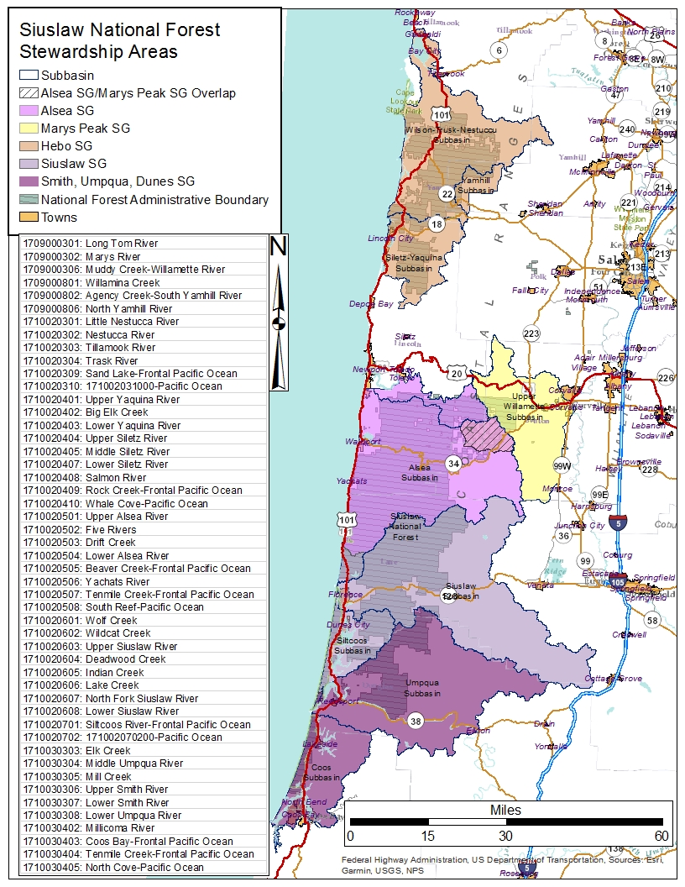

APPENDIX B: Eligibility Guidelines for Stewardship Fund Projects

PROHIBITED Project Types and Activities
In general, Stewardship funds are limited to on the ground projects. The following activities cannot be funded and must be funded with matching funds.
  - Indirect Administration
  - Analysis/Research, Surveys, Inventories or Evaluation (except for Section 106 Cultural Resource Surveys)
  - Monitoring or Maintenance (Project level monitoring and inventory is recommended to be included in stewardship project proposals, however those tasks must be funded through in-kind work or other match sources)
  - Education or Signage
  - Technical/Engineering Design or NEPA Planning
  - Capital improvements (e.g., permanent structures such as bridges, footings, and concrete abutments etc.).

ACCEPTED Project Types and Activities
Terrestrial Projects
- Development of late-successional habitat
- Habitat improvement for neotropical migratory birds
- Dune protection and restoration
- Creation or improvement of upland meadows, or other early and mid-seral habitats for rare/unique species or elk forage
- Projects should be located within a 1 ½ miles of Siuslaw National Forest lands (based on the home range
radius of the northern spotted owl and elk movement).
Aquatic Projects
- Opening additional fish passage to at least ¼ mile of fish habitat
- In-stream projects that will improve fish spawning, rearing and thermal refuge habitat
- Culverts and boxed culverts (purchase and placement only-no technical design)
- Noxious weed control
- Riparian planting
- Upgrades to poor road and trail system
- Road decommissioning
- Improvements to sanitation facilities
- Clean-up of dumpsites
- Riparian and Wetland Projects
  - Riparian projects that benefit water quality (especially temperature and sediment)
  - Long term in-stream habitat recovery and nutrient contribution
  - Tidal wetland projects that remove dikes and restore tide channels
  - Projects in sub-watersheds containing National Forest lands would be higher priority than projects in sub-watersheds with no National Forest lands.
- Water Quality Projects
- Projects that reduce point and non-point sources of pollution will be considered
- Upgrades to road and trail drainage
- Road decommissioning
- Improvements to sanitation facilities at undeveloped sites; and
- Cleanup of dumpsites that contain materials harmful to the watershed.
- Projects must demonstrate direct positive effects to water quality; mitigation work mandated by law cannot be funded.
- In-stream and Fish Passage Enhancement Projects (See Section I for design requirements)
  - Improvements to spawning, rearing and thermal refuge habitat.
  - Where migratory populations are found on NFS lands (especially anadromous or adfluvial life histories) the contribution can be direct and easy to demonstrate.
  - Where resident populations are present, benefit may be shown based on the presumption that the greater the number of fish produced within the basin, the better the resiliency of the population to recover if a catastrophic event occurs.
  - Removal of barriers downstream of SNF lands that can increase fish habitat.
Invasive Weed Control Projects
- Projects must identify weed species that have specific resource impact. See Table 1below for an invasive plant list to determine the weed species threat category:
Category A - can be anywhere in the basin;
Category B - vector or resource impact connection with NF lands needed and
Category C - adjacency to NF and resource impact needed.
Table 1
Scientific Name | Common Name | Category
Ammophila arenaria | European beachgrass | C
Brachypodium sylvaticum | False brome | A
Buddleja globosa | Butterflybush | B
Calystegia sepium | Hedge bindweed | C
Centaurea maculosa | Spotted knapweed | B
Centaurea pratensis | Meadow knapweed | B
Centaurea solstitialis | Yellow starthistle | B
Cirsium arvense | Canada thistle | B
Cirsium vulgare | Bull thistle | B
Clematis vitalba | Clematis | B
Cortaderia selloana | Pampass grass | B
Cytisus scoparius | Scotch broom | C
Cytisus striatus | Portuguese broom | B
Digitalis purpurea | Foxglove | C
Elodea densa | So. Am waterweed | A
Geranium robertianum | Robert’s geranium | C
Hedera helix | English ivy | C
Ilex aquafolium | English holly | C
Impatiens glandulifera | Policeman’s helmut | B
Iris pseudacorus | Flag iris | B
Lamiastrum galeobdolon | Yellow archangel | A
Lathyrus latifolius | Everlasting peavine | C
Leucanthemum vulgare | Ox-eye daisy | B
Linaria dalmatica  Lythrum salicaria Myriophllum aquaticum Phalaris arundinacea Polygonum cuspidatum Polygonum polystachyum Polygonum sachalinense  Rubus armeniacus  Rubus laciniatus  Sasa palmate  Senecio jacobaea  Ulex europaeus | Dalmatian toadflax Purple loosestrife Parrot feather  Reed canary grass Japanese knotweed Himalayan knotweed Giant knotweed  Himalaya Blackberry  Evergreen blackberry  Bamboo  Tansy ragwort  Gorse | B  A A  C A  A  A  C  C  C  B  B

ACCEPTED Project Implementation Activities (that may be included but are not limited to)
Pre-Implementation: Activities must directly support project implementation. These activities may include:
- Coordination with landowners, organizations, contractors or agencies involved in project implementation;
- Pre-work meetings with contractors or cooperators;
- Travel to meetings associated with the implementation of the project.
Implementation: Activities paid for with stewardship funds must be in direct support of on the-ground implementation of the project and may include:
- On-the-ground work or supervision of project work;
- Administration of implementation contracts;
- Inspection and acceptance of work;
- Coordination of landowners, volunteers, other groups or agencies involved in project activities;
- Travel to project sites.
Post Implementation: Activities are limited to legal reporting requirements of any permits or activities associated with on-the-ground implementation and accomplishment reporting required for stewardship-retained receipts.

APPENDIX C: Siuslaw Stewardship Watershed Restoration Program (SSWRP) Fund History
During the post WWII era, improved access to interior coastal forests and rivers resulted in booming economies throughout central Oregon coastal communities. Timber harvest and production on the Siuslaw NF was at its peak from 1960-90, averaging 380 million board feet (mmbf) per year. Intensive harvesting practices affected the forest ecosystem and its fish and wildlife populations. Impacts to watersheds included highly eroded streambanks, poor water quality, and impacts to critical fish habitat. Concerns about these impacts were voiced by citizens, stakeholders, local groups, and environmental activists.By 1992 the annual timber harvest was reduced from 380 to 5 mmbf due to the litigation in 1988 that became known as the Headwall Injunction. The Region 6 Northwest Forest Plan (NWFP) was approved in 1994. Legal restrictions focused the harvesting of trees to 80 years and younger. The decline of timber harvest revenues severely affected the SNF budget as well as the local communities.
From 1995-1998, collaborative efforts between the SNF staff and key stakeholders led to the process of addressing critical watershed restoration and forest management issues in and around the forest. Watershed assessments determined that 70-80% of the best habitat for threatened salmon was on private lands in the lower gradient reaches of the coastal watersheds. However, USFS funds were not permitted for use on private lands.
The vision and revolutionary concept of retaining the revenue from stewardship timber sales became known as the Siuslaw Option. Today, these retained receipts are identified as the Stewardship Fund.
The SNF developed the idea to allow commercial thinning within the LSR areas through stewardship contracting. In 1998 the Wyden Amendment to the Appropriations Act was passed. The Appropriations Act allowed the USFS and BLM to use retained receipts from stewardship contracting for projects that demonstrated improvements to whole watershed health and local communities.
From 1999 to 2002 Congress authorized the USFS to establish 84 stewardship contracting pilot projects nationwide. The Green Thin was the first SNF pilot stewardship contract, awarded in 2002 to Georgia Pacific to thin 900 acres of small diameter trees. In 2003 Congress passed the Healthy Forests Restoration Act (also known as Stewardship Contracting Authority), authorizing the Wyden Amendment for 10 years. Congress granted permanent authority under the 2014 Farm Bill. Today, the SSWRP has funded and restored thousands of acres of watersheds within and surrounding the SNF.

APPENDIX D: Common Mitigation Measures
Please use these when developing your project if they are relevant

Silviculture
- If planting, ensure proper sanitation procedures are implemented during nursery operations
Wildlife
- For projects within 1.5 miles of the SNF managed lands:
- If the project proposes to operate noise-creating equipment within 110 yards of mature habitat for Marbled Murrelet habitat, follow seasonal protection measure of no noise from April 1 – August 5 and from August 5 – September 15 (no noise 2 hours after sunrise and 2 hours before sunset).
- If the project proposes to operate within an Activity Center of a Northern Spotted Owl, follow protection measures of no removal of trees greater than 11”; and all noise disturbing activities take place July 8 – February 28.
- Consider wildlife friendly fencing for projects placing new fence line.
Botany
- A planting plan is needed if this activity is part of the project. Planting plans just need to include what you will plant, how much and from what source. Use of local or regional planting mix is best.
- Grasses should only be native – non-natives can create a future problem and inhibit natives species.
- When using herbicides, time it prior to any flowering of invasive forbs to protect pollinators.
Engineering
- Document notification of any affected third party Rights-of-Way holders and obtain any required permits or licenses.
Fisheries
- Any culvert replacements need to match stream size.
- Use buffers below when using herbicides near streams unless it is a drinking water source and then the buffer is 1,000 feet or the instructions on the herbicides are greater.

Table A - 11. Herbicide-use buffers for streams, wetlands, lakes, ponds, and high-water-table areas.
Herbicide | Application Method – Spot | Application Method
Clopyralid | 15 feet | Bankfull
Glyphosate – aquatic formulation | Waterline | Bankfull
Imazapyr – aquatic formulation | Waterline | Bankfull
Sethoxydim | 20 feet | 50 feet
Triclopyr (aquatic) | 15 feet | Waterline

APPENDIX E: Vicinity Map Examples
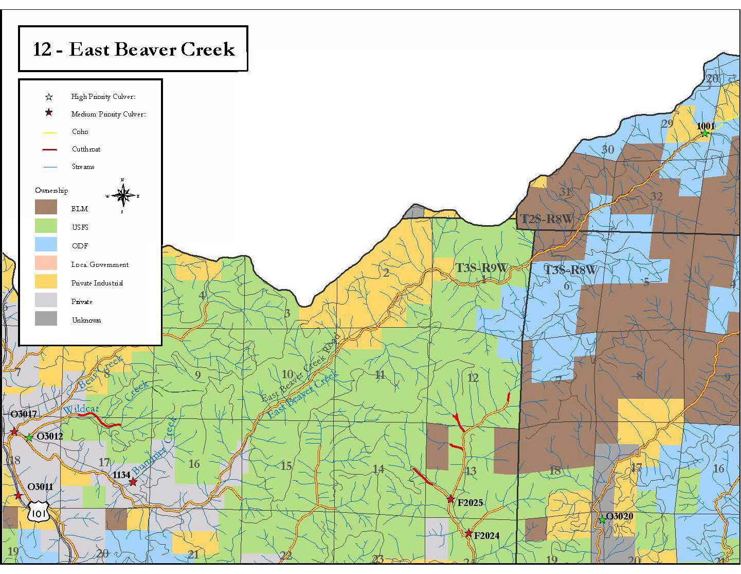

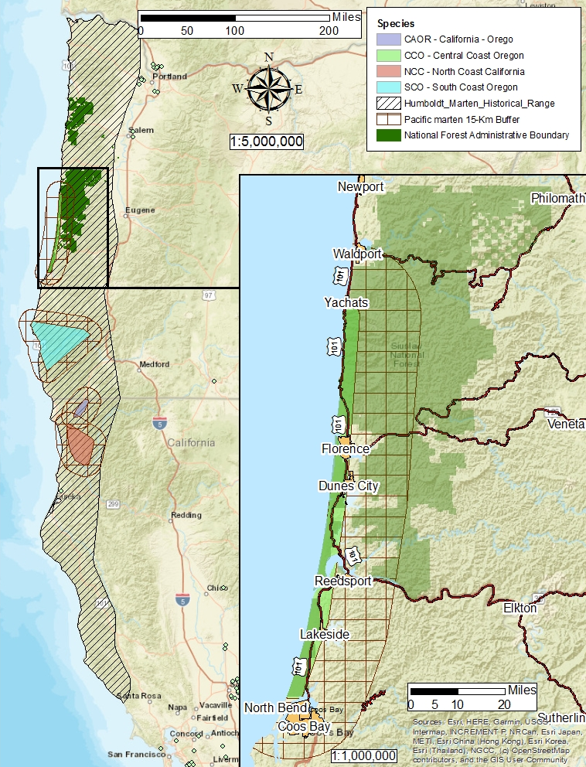

APPENDIX F: Site Plan Map Examples
